Want to Create Transformational Change in your Community, Church, or Business?

Attend “When Heaven Meets Earth: A Creation Care,
Conflict Management and Sustainability Practicum”

Sponsored by The Center for Law and Culture at Olivet Nazarene University

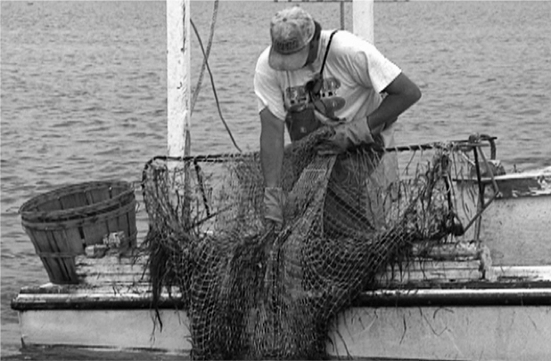

This one-day practicum will explore the application of transformational change catalyst principles and biblical principles of stewardship, conflict management and sustainability to an environmental conflict in the Chesapeake Bay and a racial and environmental conflict in the Delaware Bay. The practicum is based on Emmerich’s faith-based stewardship and reconciliation work on Tangier Island shown in her film When Heaven Meets Earth: A Faithful Few Changed Everything and her racial reconciliation work in Berlin, Maryland shown in her trailer film “Minority Outreach in Berlin, MD.”. Participants will learn methods and principles immediately applicable to their communities, businesses, and churches.

Instructor Dr. Susan Emmerich

Location Olivet Nazarene University, Room: Weber 204
When May 18, 8:30 a.m. – 4:00 p.m.

Enrollment Open to students, faculty and the public.

Cost With the Richard Acker Creation Care Scholarships, we can offer this practicum at a very low price of $10 for students and ministry workers, and $40 for faculty and the general public. Lunch is provided.

Registration May 17, 2024
Deadline

Syllabus See back.

Registration See back.

Questions? Contact Jenny Diamico, CLC Administrator, at jadiamico@olivet.edu and 630-915-0385.

The Center for Law and Culture
Olivet Nazarene University, 1000 University Avenue, Bourbonnais, IL 60914
Phone: 815.928.5552 | www.lawandculture.org | lawandculture@olivet.edu

When Heaven Meets Earth:
Creation Care, Conflict Management and Sustainability Practicum
Sponsored by The Center for Law and Culture

Participants will learn methods, approaches, and principles for instituting transformational change and conflict management including participatory action research, inter-cultural communication, interpersonal ethnography along with the application of these approaches to two case studies involving environmental and racial conflict.

Morning:
8:30 – 10:00 a.m. Introduction, overview of methods, mindsets & behavior approaches related to
roots of conflict.
10:00-10:10 a.m. Break
10:10 –11:00 a.m. Discussion of Biblical principles of environmental stewardship and review of
conflict management and sustainability approaches.
11:00 – 11:10 a.m. Break
11:10-11:50 a.m. Group Analysis of Stewardship Initiative documents
11:50 - 12:30 p.m. Class discussion of each principle and applicability to own lives and community
12:30 – 1:20 p.m. Lunch & viewing of full-length film When Heaven Meets Earth

Afternoon Session
1:20- 2:20 p.m. Details of the methodological keys to successful transformational change
2:20 – 2:30 p.m. Break
2:30- 3:10 p.m. Introduction to Berlin, MD Case Study of environmental and racial conflict
breakout groups and discussion
3:10 – 3:20 p.m Break
3:20 – 3:40 p.m. Class answers group questions together
3:40 - 4:00 p.m. Open Q&A

Those interested in enrolling in “When Heaven Meets Earth: A Creation Care, Conflict Management and Sustainability Practicum” should email the information requested below to Jenny Diamico by May 15 and then bring check or cash the day of the Practicum. If you must cancel for reasons of emergency, please be respectful and let Jenny know two days before beginning of the practicum since we produce binders for the course and set up teams for the day.

Name: _______________________________________________________________________________
Last First Middle Initial

Address: ____________________________________________________________________________
Street City State Zip Code

Cell Phone: _____________________________________ Other Phone: ________________________
E-Mail: ______________________________________________________________________________

College (if applicable): _________________________________________________________________

Major (if applicable): ______________________________ Minor (if applicable): _________________

Dietary Restrictions; list is applicable: ___________________________________________________

